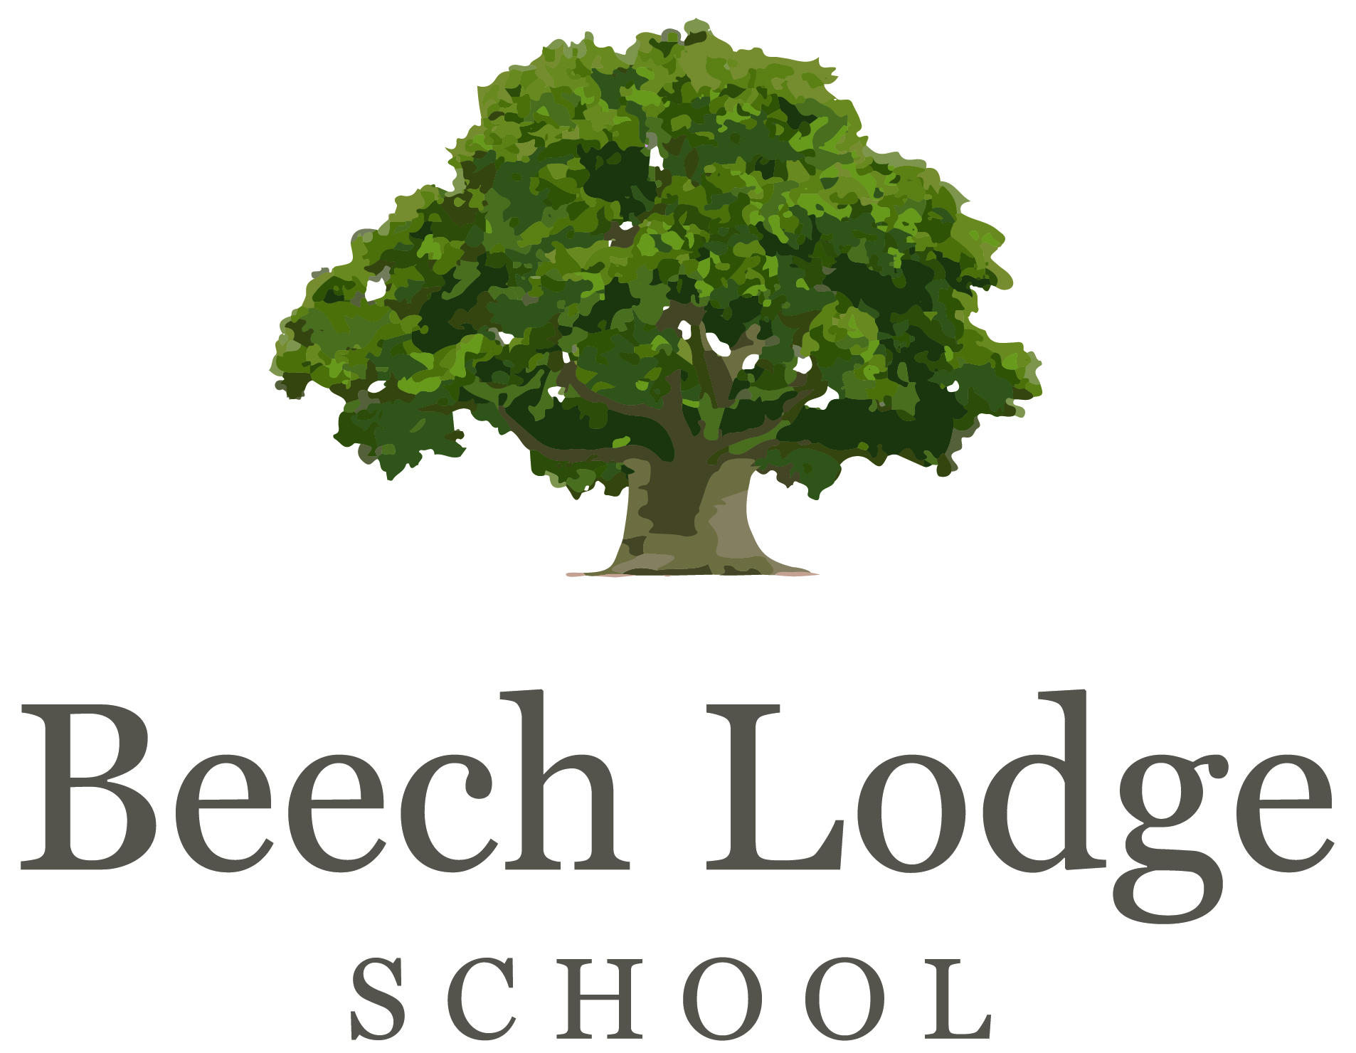

Transition Hub Learning Mentor
Job description and Personal specification

ABOUT US
Founded in 2015 Beech Lodge School is a very small, thriving independent, special school in Berkshire for pupils aged 7-18, who may have been failed by mainstream education and have needs that are difficult to meet in a conventional school setting. We have recently moved into brand new purpose built state-of-the art premises and we are looking to expand our staff team.

JOB DESCRIPTION
As a learning mentor at Beech Lodge School, you will work both independently and alongside the teaching and pastoral staff to support the academic, emotional, social and mental health needs of our pupils, all of whom have not thrived in the mainstream system.
You will work primarily with pupils in Key Stage 3 and 4 in our Transition Hub where pupils who are currently unable to access the main school environment are taught. You will work mainly on a one to one basis with individual pupils or in a small group, delivering academic and social and emotional programmes.
Whilst your work will be primarily with our pupils, you will have a broader remit including working alongside our families and the wider school community.
You will need experience of working with vulnerable and challenging young people. You will need to manage your own case load and plan, deliver and measure interventions to support the young people you work with.
You may not be the world’s best climber, hiker and identifier of trees. You may not have the knowledge of how to avoid the particularly sticky mud which seems to coat each and every Beech Lodge member after a day in the woods, but with us and our pupils you will learn.
You may not be a dog person but you must be up for Meghan the Collie’s attempts for you to pat her and for Rufus the Labrador’s lopsided grin.

Your role will include:
- Establish productive working relationships with pupils, acting as a role model and setting high expectations
- helping learners who are underperforming in their subjects, either on a one-to-one basis outside the classroom or within lessons;
- implementing strategies and supporting learners in self-esteem and confidence-building activities;
- listening to and helping learners resolve a range of issues that are creating barriers to learning;
- drawing up agreed action plans with learners, outlining the aims of the mentoring, and monitoring their progress;
- liaising with parents to discuss issues and problems and possible solutions
- advising parents on behaviour strategies and parenting skills;
- networking with other learning mentors, teachers and relevant external agencies;
- liaising with relevant professionals and individuals, e.g. educational psychologists and therapists
- running extracurricular activities, such as homework clubs, reading clubs, sports and music during lunchtimes or as out-of-school activities, and potentially one week of activities in the Summer holidays;
- maintaining accurate records and preparing written reports and evaluations;
- managing your own professional development through undertaking relevant training and sharing best practice with other learning mentors;
- helping with transition activities for learners moving to the main school or on to further education.
PERSON SPECIFICATION
- Excellent inter-personal skills
- Good ICT skills (Word, Excel)
- Good level of education and qualifications
- Ability to work well under pressure
- An understanding of the links between therapy and education
- High expectations of all children and a strong commitment to education for all
- Demonstrates PACE* characteristics: Playful, Accepting, Curious and Empathic
- Initiative, drive and enthusiasm
- Flexibility
- Good sense of humour
*Dan Hughes PACE Method www.ddpnetwork.org
SALARY
Circa £19,000 to £21, 000 ( Paid 46 weeks of the year ( 39 weeks directed, 7 weeks paid holiday).

WORKING HOURS
Working hours are usually 40 hours, Monday to Friday during term time. Some evening and occasional weekend work is necessary on, for example, extra-curricular activities. There will potentially be one week of activities during the Summer Holidays.

QUALIFICATIONS
Experience and the right mindset are more important than formal qualifications, but having studied psychology or early childhood studies may be an advantage. You will need sound levels of English and Maths ie GCSE in order to be able to support pupils studying for Level 2 qualifications.

Beech Lodge School is an equal opportunities employer and committed to safeguarding and promoting the welfare of children and young people and expects all staff to share this commitment. A DBS check at an enhanced level is required for the successful applicant.

