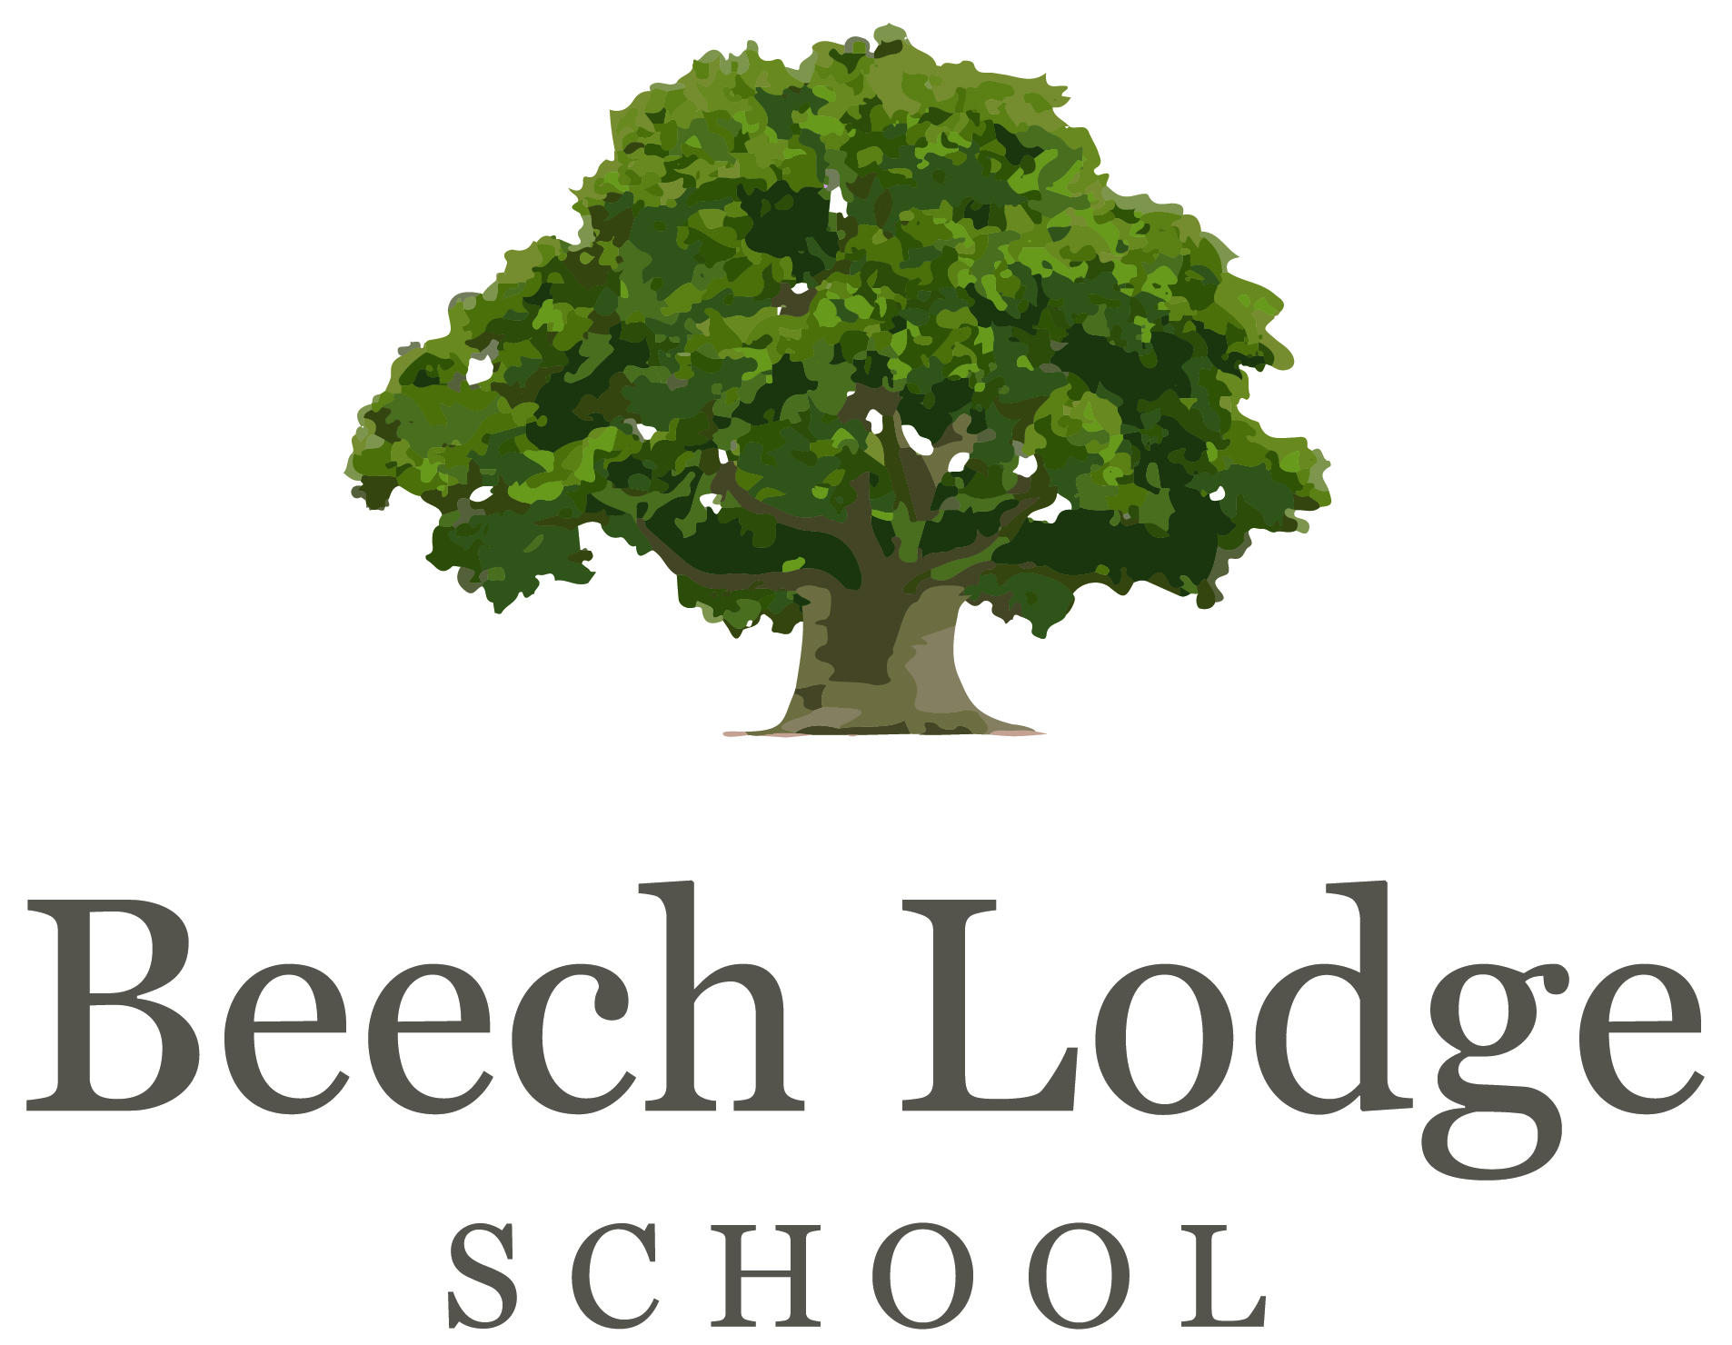

Some very good questions from a prospective pupil.

What time do we have to be at school?

From September lessons will start at 9.00am so you should be here by 8.55am to make sure you are on time. The earlier you arrive, the more Rise and Shine time you will have! You can arrive from 8.30am.

What happens in the school day?

We haven’t finished planning the timetable for next year yet but we know that it will look fairly similar to this year’s timetable (except lessons will start at 9.00am):

8.30am - 9.15am | Rise and Shine
9.15am - 10.45am | Classroom Learning (Literacy)
10.45am - 11.15am | Break Time
11.15am - 12.45am | Classroom Learning (Maths)
12.45pm – 1.30pm | Lunchtime
1.30pm – 2.30pm | 1 or 2 lessons depending on the subject:  Science, History, Geography, Art, Food Tech, D+T, Forest Schools,
2.30pm – 3.15pm
3.15pm | Home Time

We will send you your timetable as soon as we know what it will be.

You may also join us for after school club. We have an after school sports club and a kick boxing club. Otherwise, it is a time for you to do your homework, spend time with friends or relax on your own.

Where do we go in the morning?

You will be dropped off at the Blossom House building on the BCA site in September. When you arrive at school you should make your way inside and hang your bag and coat up. From September we will have ‘Rise and Shine’ time in the morning from 8.30am until 9.00am. During this time you can choose what you would like to do. You may choose to be inside or outside. There are games you can play, you can talk with friends or you may prefer to lie on a bean bag and chill out. Our chill out room is a great place to relax. You can bring a bike or scooter in from home to use outside if you would like to. Members of the staff are around for you to have a chat with and to help you settle into the school day.

Where do we put our bags?

When you come for you visit days you can put your bag in the upstairs room. Once you start properly at Beech Lodge you will have your own peg. Each peg has a name above it so you know where to put your bag.

Do we get lockers?

We do not have lockers at Beech Lodge School. If you have anything that you would like us to keep safe, give it to a staff member when you arrive and we can look after it for you.

Where do we put our PE stuff or spare clothes?

These live in a bag on your peg. You can take them home when they need washing.

Do we have loads of books to take home or do we leave them at school?

Most of the time you will leave your books at school. There may be times when you need your books to complete homework – your teacher will tell you when you need to take them home.

What do we do at lunchtime?

We have lunch time clubs which you can join if you would like to - these include arts and crafts, woodwork, computer and sports club. You can also bring a bike or scooter in to use at lunch time. There are plenty of games for you to play, books to read and places to relax.

What subjects do we have?

Art, Design and Technology, English, Food Technology, Forest Schools and Outdoor Learning, Maths, History, Geography, PSHE, Science, Textiles.

What are the subject choices for GCSE?

Art, English, Food Technology, History, Geography, ICT, Maths Science, Textiles.

Do we do a language?

No but as we get bigger languages will be offered for those who want to study them.

Do we have lessons with younger or older kids?

From September, children in year 7 and above will be at our Blossom House site. During your morning lessons (English and Maths), everybody in your class is between year 7 and year 10.

In the afternoons the 2 classes at Blossom House will be mixed together. Everybody will be in years 7 to 10.

Do we have to do ice skating or any activities on water?

We would like you to give all activities a try but we won’t make you do anything if you really do not want to. Sometimes pupils think that they are going to hate an activity and end up loving it, so we do think that it is important that you try to give it a go! Some people go and watch to begin with and then join in after 3 or 4 weeks.

How many people will be in my year when the school moves location?

No more than 8.

Will the teacher pick on me to answer questions?

No. If we know that you do not like speaking out loud in class we will not pick on you to make you. We will look at others ways that you can answer the teachers’ questions, such a writing your answers down. Once you become a bit more settled at Beech Lodge, we will work with you to help build your confidence and move towards the goal of being able to answer questions out loud in class. This may take time and that is OK – we are here to work with you and help to makes things that you find difficult easier.

What do we do for exercise in the day?

We have a several different ways to exercise. Through the week we will go on class and whole-school walks, Forest School (which involves walking, using our muscles to build things and outdoor activities), PE and games sessions. During free time sessions we have sports club, bikes and scooters outside, an exercise bike and opportunities to go on walks with staff. Some staff can also take you out on a run during free time sessions if you would like to.

Can we wear our hair down?

Most of the time yes. There may be times in some lessons when you need to put your hair up for health and safety reasons, such as during practical sessions in food technology, forest school, science and woodwork.

If we wear shorts, what length do they have to be?

Just above the knee.

Are we allowed phones ?

In Key Stage 3 (years 7-9) you can bring phones to school but you cannot use them during the school day. You are allowed to use your phone at after school club.

Where do we put our phones?

You can keep your phone in your bag, or give it to staff to keep safe for the day.

Are the people friendly?
The members of staff at Beech Lodge School ensure that we are as approachable and friendly as we can be. We want you to feel comfortable enough to talk to us about anything. Lots of our young people want strong and lasting friendships but find them difficult. Like anywhere, there may be disagreements between friends but we work really hard to help pupils resolve these issues when they do happen.

