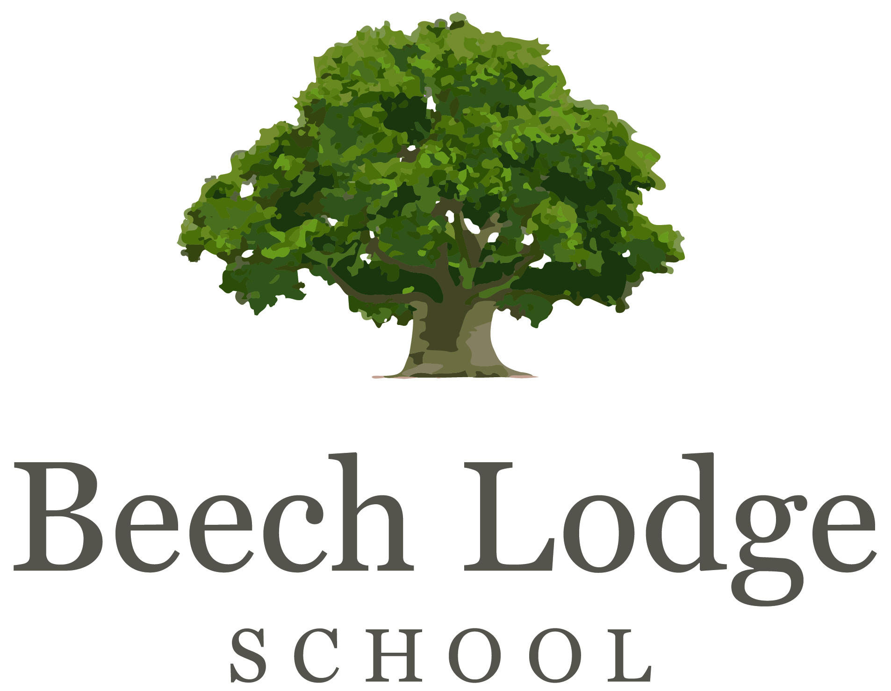

PERSON SPECIFICATION

Deputy Head Teacher
Required for September 2016

Qualifications / Experience
- Qualified Teacher Status
- Minimum 2 years leadership and management experience in a Secondary School setting (mainstream or special school)
- Minimum 5 years teaching experience
  - Maths would be desirable

Specialist Knowledge
- Awareness of all relevant government initiatives
- Knowledge and experience of current good practice and development in SEN
  - Knowledge of Attachment Theory and Developmental Trauma would be a distinct advantage
  - Knowledge of a range of difficulties and disorders including ADHD, ASD, Dyslexia, Speech & Language and Sensory Processing difficulties would be desirable
- Awareness of practices and procedures relating to the welfare and safety of children
- Experience of development of the role of curricular leaders
- Experience of target setting, individual intervention plans, budget management, Self-Evaluation Summary and Learning Improvement plan development
- A proven record of highly successful inclusive classroom practice and of innovative curriculum development.

Skills/Disposition

- Outstanding leadership and management skills
- Experience in monitoring evaluating and reviewing the quality of teaching and learning
- Excellent organisational and communication skills
- Outstanding teacher
- Ability to build and lead a team
- Proficient in ICT skills
- High expectations of all children and a strong commitment to education for all
- An understanding of the links between therapy and education
- Demonstrates PACE* characteristics: Playful, Accepting, Curious and Empathic

*Dan Hughes PACE Method www.ddpnetwork.org
We are very proud of our members of staff all of whom work to a very high standard. Anyone considered for a role at Beech Lodge School must embrace our aims & ethos and due to the nature of our children be prepared to form positive relationships with them, have a good sense of humour and be:

- Emotionally resilient
- Patient
- Compassionate
- Energetic
- Adaptable
- Practical
- Robust
- Encouraging
- Motivating
- Enthusiastic
- Reflective
- Playful
- Accepting
- Curious
- Empathic
- ……..and prepared to get muddy!

Beech Lodge School is an equal opportunities employer and committed to safeguarding and promoting the welfare of children and young people and expects all staff to share this commitment. A DBS check at an enhanced level is required for the successful applicant.

